Predict how the valence electrons in iron metal (iron 0) should be organized. 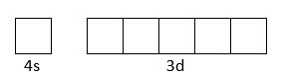
A. 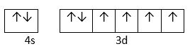
B. 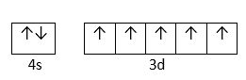
C. 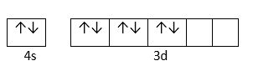
D. 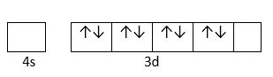
ANSWER: A
Which of the following are d-block elements, but not regarded as transition elements?
a) Ru, Ag, Au
b) Zn, Ru, Pd
c) Zn, Cd, Hg
d) Cd, Rh, Pd
Answer: c
Why do transition elements form alloys so easily?
a) Atomic size
b) Orbital configuration
c) Very light
d) Hard elements
Answer: a
Which of the following has the highest atomic number?
a) Scandium
b) Titanium
c) Cadmium
d) Lanthanum
Answer: d
What is the oxidation state exhibited by actinium?
a) +4
b) +1
c) +2
d) +3
Answer: d

Where does the last electron of d-block element go?
a) nd
b) (n-1)d
c) np
d) (n-1)s
Answer: b
Which of the following is the correct electronic configuration of Zn-30?
A. $\left[Ar\right]3d^{7}4s^{2}$
B. $\left[Ar\right]3d^{8}4s^{2}$
C. $\left[Ar\right]3d^{10}4s^{1}$
D. $\left[Ar\right]3d^{10}4s^{2}$
ANSWER: D

Which of the following is the correct electronic configuration of Co-27?
A. $\left[Ar\right]3d^{7}4s^{2}$
B. $\left[Ar\right]3d^{8}4s^{2}$
C. $\left[Ar\right]3d^{10}4s^{1}$
D. $\left[Ar\right]3d^{10}4s^{2}$
ANSWER: A
Why does Zinc not show variable valency?
a) Complete ‘d’ subshell
b) Inert pair effect
c) 4s2 subshell
d) 4s3 subshell
Answer: a
What is the common oxidation state of scandium? (At. No. of Sc = 21)
a) +4
b) +3
c) +1
d) +5
Answer: b
Which of the following statement is correct?
a) The properties of various actinoids are very similar
b) 4f and 5f orbitals are equally shielded
c) D-block elements show irregular and erratic chemical properties
d) 4d and 5d orbitals are equally shielded
Answer: c
Electronic configuration of $Cu$ and $Cu^{1+}$are.
A. $3d^{10}4s^{0} ; 3d^{9}4s^{0}$
B. $3d^{9}4s^{1} ; 3d^{9}4s^{0}$
C. $3d^{10}4s^{1} ; 3d^{10}4s^{0}$
D. $3d^{8}4s^{1} ; 3d^{10}4s^{0}$
ANSWER: C
Which of the following is the correct electronic configuration of Cu-29?
A. $\left[Ar\right]3d^{7}4s^{2}$
B. $\left[Ar\right]3d^{8}4s^{2}$
C. $\left[Ar\right]3d^{10}4s^{1}$
D. $\left[Ar\right]3d^{10}4s^{2}$
ANSWER: C
Which of the following is the correct electronic configuration of Ni-28?
A. $\left[Ar\right]3d^{7}4s^{2}$
B. $\left[Ar\right]3d^{8}4s^{2}$
C. $\left[Ar\right]3d^{10}4s^{1}$
D. $\left[Ar\right]3d^{10}4s^{2}$
ANSWER: B
Which of the following elements have irregularities in electronic configuration?
A. Cr
B. Zn
C. Fe
D. V
ANSWER: A

